**19CSE303 – EMBEDDED SYSTEMS**

**Lab 6 – 23.08.2021**

**Practice Lab (Arrays)**

* **R.Abhinav**
* **CB.EN.U4CSE19453**

1. **Declare array:**

AREA array_traverse_up, CODE, READONLY

ENTRY

adr r2, array

mov r1, #0

loop cmp r1,#6

bge done

ldr r3, [r2, r1,LSL #2]

adds r1, r1 ,#1

b loop

done b done

align

array dcd 1,2,3,4,5,6

end

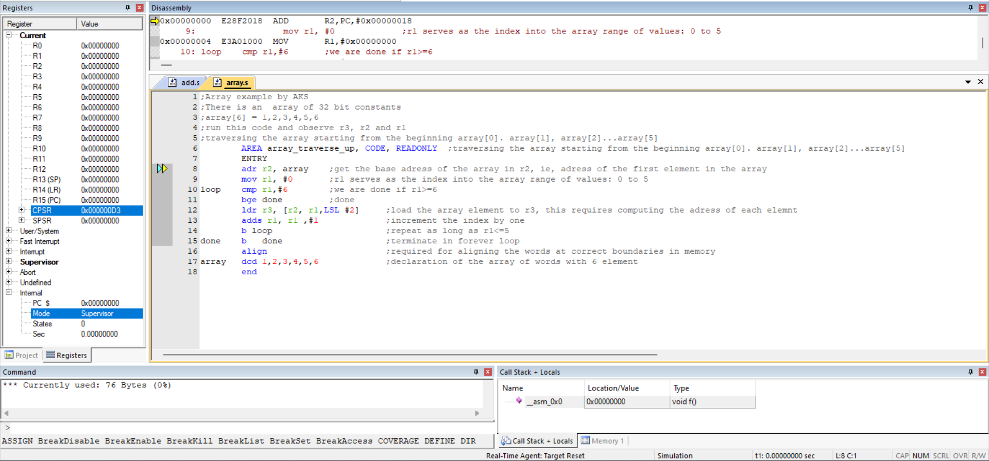

1. **Add:**

AREA myadd, CODE, READONLY

ENTRY

mov r0, #1

mov r1, #2

add r2, r0, r1

add r1,r1,#1

swi &11

end

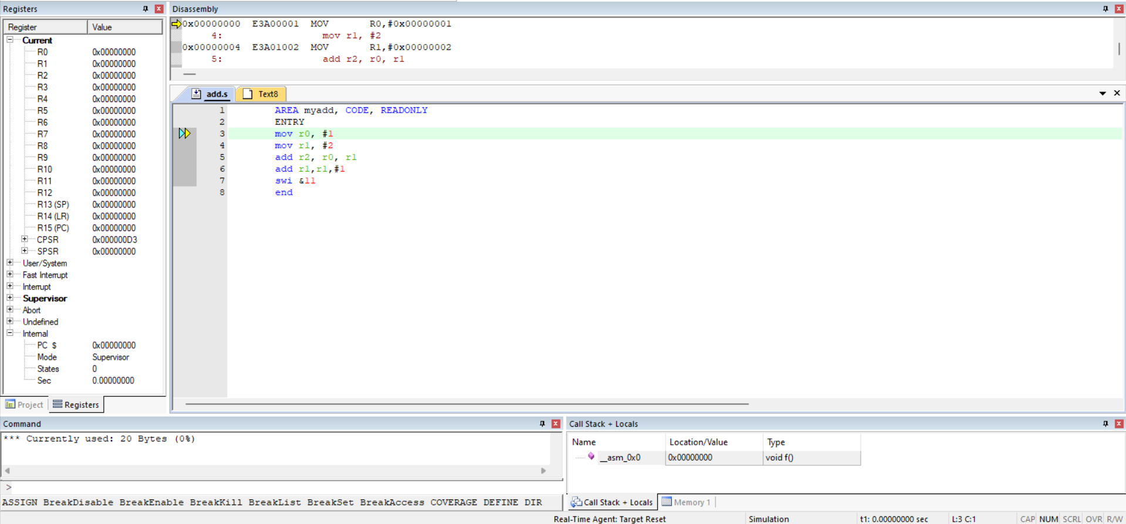

1. **Simple :**

;16 bit data transfer

TTL move16 – 16-bit data transfer

AREA Program, CODE, READONLY

ENTRY

Main

LDRB R1, Value ; Load value

STR R1, Result ; Sore it again

SWI &11 ; exit()

Value DCW &C123 ; Source value to be moved

ALIGN ; Alling next word

Result DCW 0 ; Reserve space for result

END

1. **Basic:**

AREA prog1,CODE,READONLY

ENTRY

mov r0,#0x11

mov r1,r0, LSL#1

mov r2,r1, LSL#1

stop B stop

END

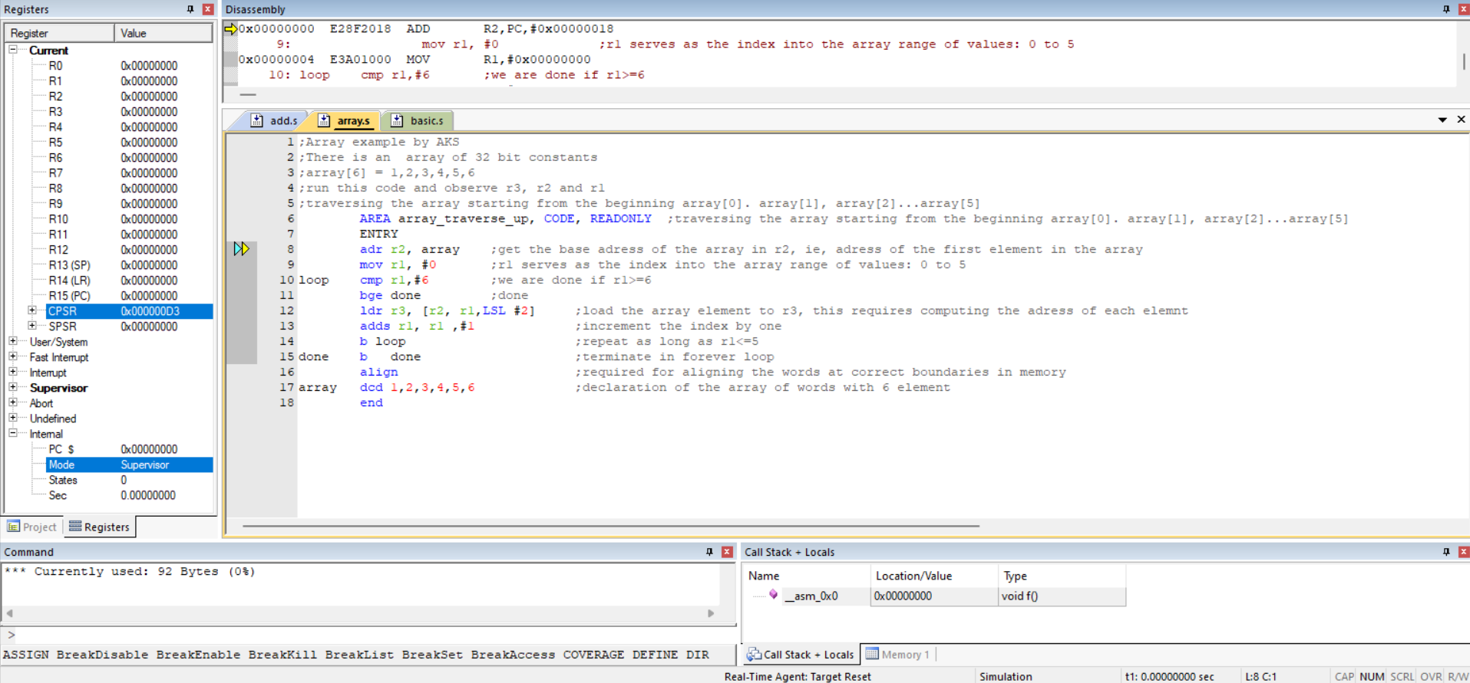

Also tried 2 pdf problems. Got some errors

1. Traverse :

AREA array_traverse_up, CODE, READONLY

ENTRY

adr r2, array

mov r1, #0

loop cmp r1,#10

bge done

ldr r3, [r2, r1,LSL #2]

sub r3, r3, #1

str r3, [r2, r1,LSL #2]

adds r1, r1 ,#1

b loop

done b done

align

array dcd 1,2,3,4,5,6,7,8,9,10

end

